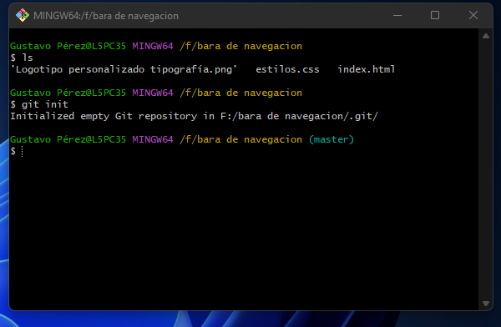

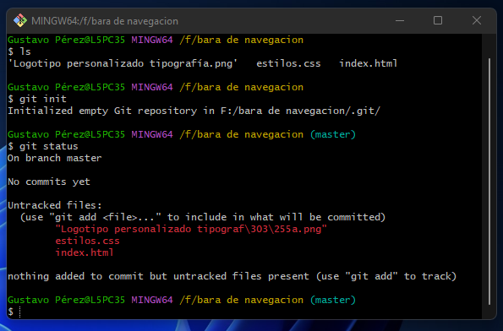

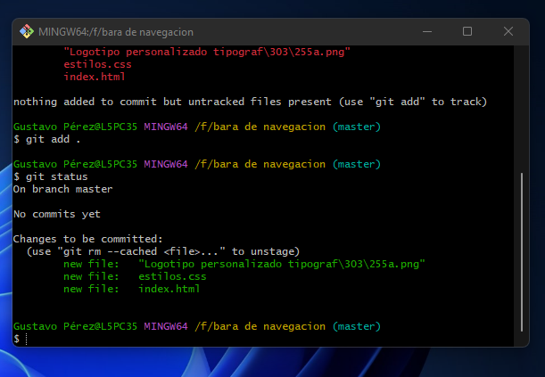



Codigo HTML.

<!DOCTYPE html>

<html lang="en">

<head>

    <meta charset="UTF-8">

    <meta http-equiv="X-UA-Compatible" content="IE=edge">

    <meta name="viewport" content="width=device-width, initial-scale=1.0">

    <title>Barra de navegacion</title>

</head>

<body>

    <header>

        <a href="#" id="logo-empresa">

            <img src="Logotipo personalizado tipografía.png" alt="logitipo" id="logo">

            <h2 id="empresa">Mega Bite</h2>

            <link rel="stylesheet" href="estilos.css">

        </a>

        <nav>

            <a href="#" class="link-nav">Inicio</a>

            <a href="#" class="link-nav">Nosotros</a>

            <a href="#" class="link-nav">Contacto</a>

            <a href="#" class="link-nav">Redes Sociales</a>

        </nav>

    </header>

</body>

</html>

Codigo CSS

\*{

    box-sizing: border-box;

    margin: 0;

    padding: 0;

}

body{

*/\* background: linear-gradient(150deg, rgb(240, 38, 240),  #360388); \*/*

    background: linear-gradient(rgba(240, 38, 240, 0.5), #360388), url(*Logotipo\* *personalizado\* *tipografía.png*);

    background-repeat: no-repeat;

    background-size: cover;

    height: 100vh;

}

header{

    display: flex;

    justify-content: space-between;

    background:rgb(0, 0, 0);

    align-items: center;

    padding: 10px;

}

#logo-empresa{

    display: flex;

    text-decoration: none;

    color: rgb(176, 11, 241);

    align-items: center;

}

#logo{

    height: 100px;

    width: 100px;

    margin-right: 20px;

    border-radius: 20em;

}

#empresa{

     font-size:  40px;

    font-family:fantasy;

    background-image: linear-gradient(to right, #5f02f5, #f003f0, #6c08f0);

    -webkit-background-clip: text;

    background-clip: text;

    color: transparent;

}

nav .link-nav{

    padding-right: 15px;

    font-size: 30px;

    text-decoration: none;

    background-image: linear-gradient(to right, #5f02f5, #f003f0, #6c08f0);

    -webkit-background-clip: text;

    background-clip: text;

    color: transparent;

    font-weight: bold;

}

nav .link-nav:hover{

    color:rgb(88, 10, 231);

}